1. Click the following link to be directed to the hour of code website

<https://studio.code.org/s/mc/lessons/1/levels/1>

1. This document contains suggested answers for each puzzle within the game. While these solutions are correct, they are not the only way to solve each problem. They are suggestions to help guide students through the activity.
2. The image below shows the complete code stack for puzzle 1

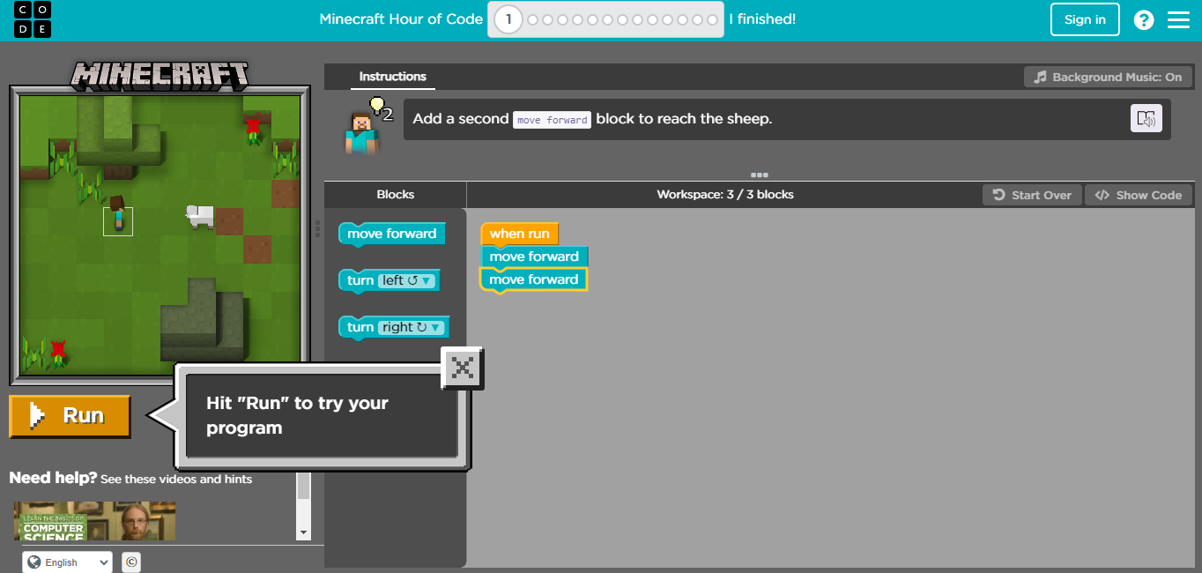

1. The completed code stack for level two is as follows:

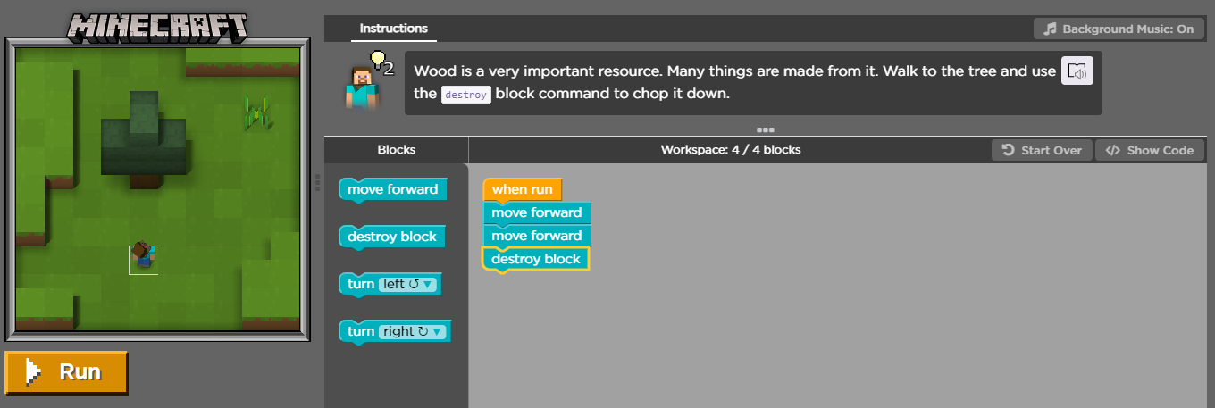

1. The completed code stack for level three is shown below

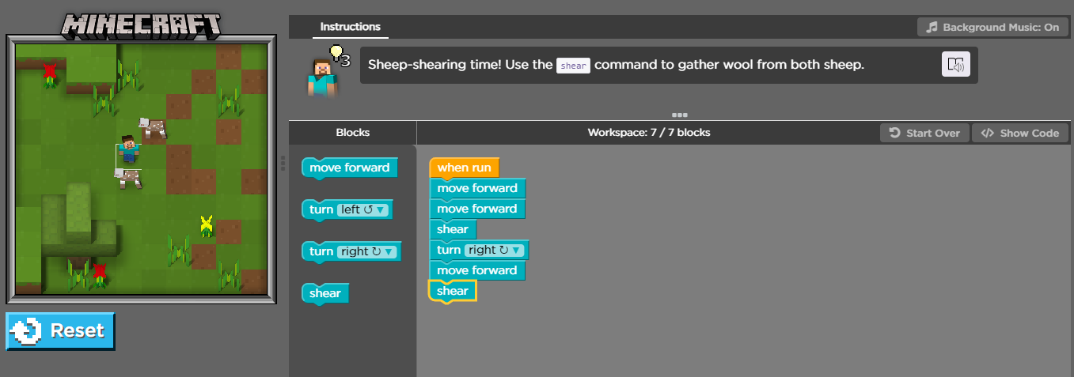

1. The completed code stack for puzzle 4 is shown below

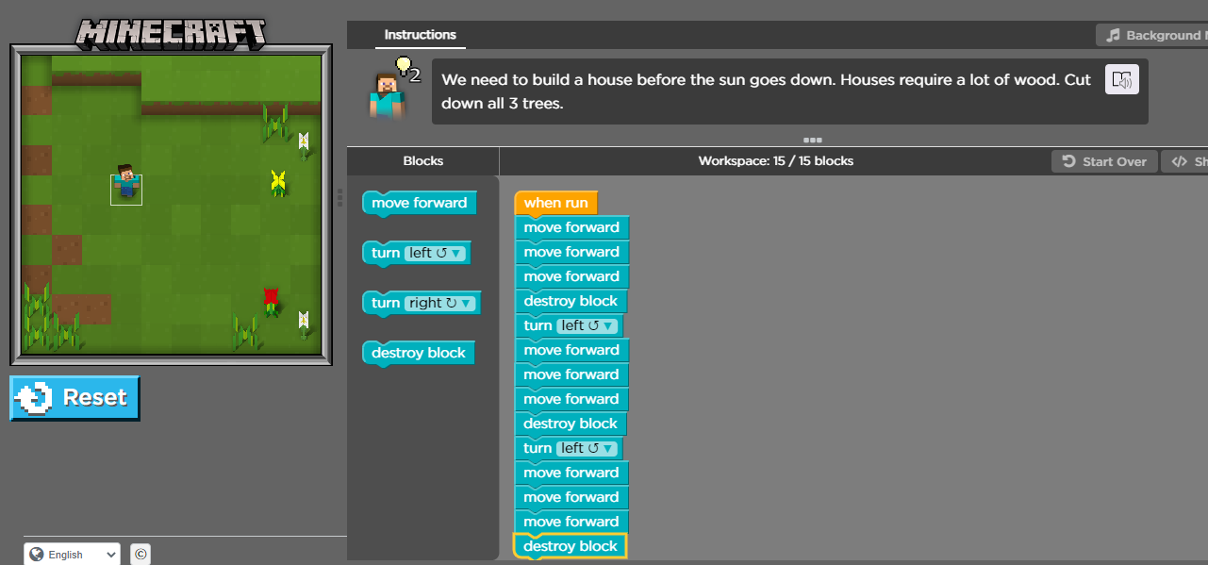

1. The image below shows the completed code stack for puzzle five using a loop

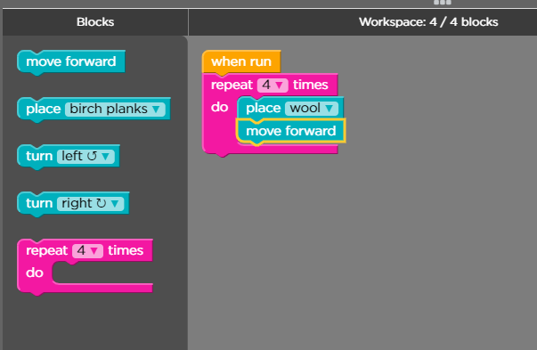

1. The completed code stack for puzzle 6 on easy difficulty is shown below

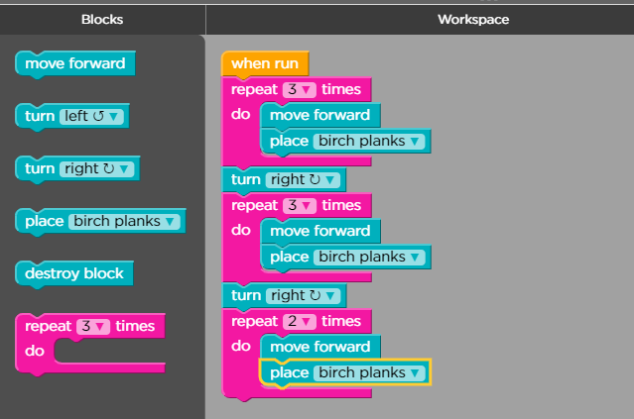

1. The completed code stack for puzzle 7 is shown below.

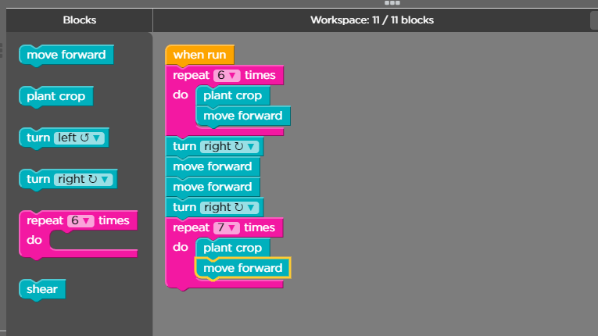

1. The completed code stack for puzzle 8 is shown below

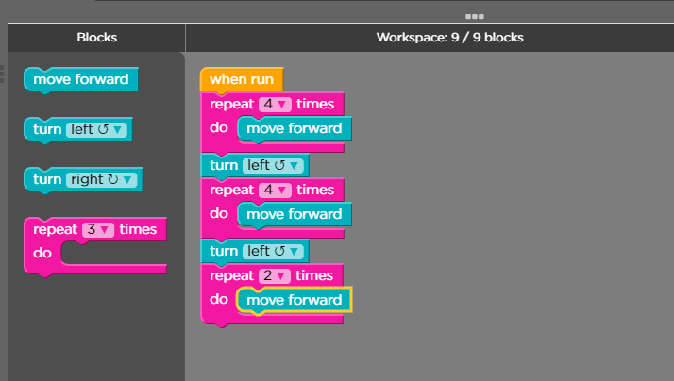

1. The completed code stack for puzzle 9 is shown below

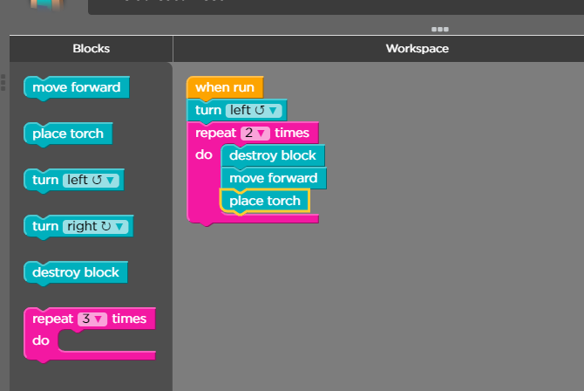

1. The completed code stack for puzzle 10 is shown below

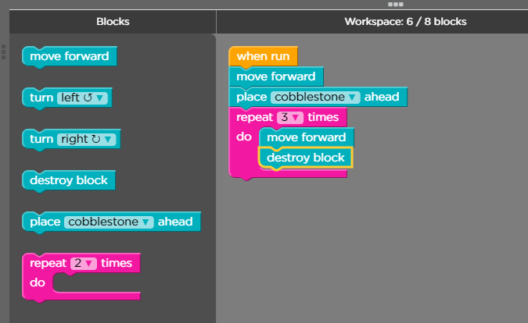

1. The completed code stack for puzzle 11 is below

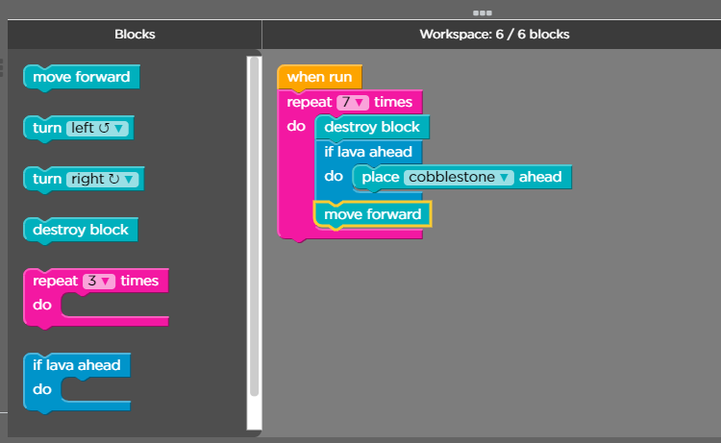

1. The completed code stack for problem 12 is shown below

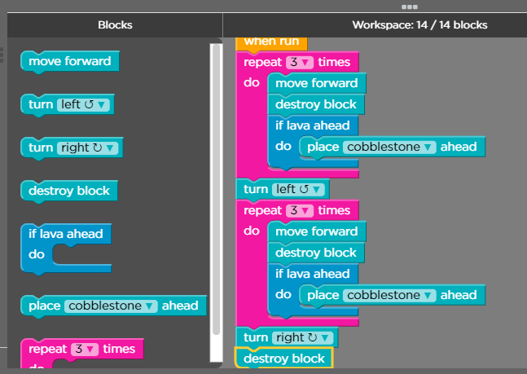

1. The completed code stack for problem 13 is shown below

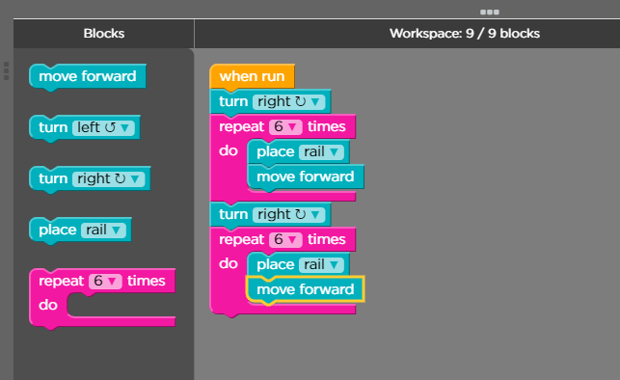

1. The tutorial is now complete and students can feel free to build their own creations!